

RAFFLES INSTITUTION
PRELIMINARY EXAMINATION 2010

Higher 1

CANDIDATE NAME

CLASS INDEX NUMBER

CHEMISTRY 8872/02

Paper 2 20 September 2010

2 hours
Candidates answer Section A on the Question Paper.

Additional Materials: Data Booklet
Answer Paper

READ THESE INSTRUCTIONS FIRST

DO NOT open this booklet until you are told to do so.

Write your name, class and index number in the spaces provided above.
Write in dark blue or black pen on both sides of the paper.
You may use a soft pencil for any diagrams, graphs or rough working.
Do not use staples, paper clips, highlighters, glue or correction fluid.

Section A (40 marks)
Answer all questions.

Section B (40 marks)
Answer any two questions on separate answer paper.  You are to begin each question on a fresh sheet of paper.  A Data Booklet is provided.  At the end of the examination, fasten all your work securely together.  The number of marks is given in brackets [ ] at the end of each question or part question.  You are reminded of the need for good English and clear presentation in your answers.
  For Examiner’s Use
  Paper 1
  Paper 2
  Section A
  B6
  B7
  B8
  Total

This document consists of 14 printed pages.
Section A (40 marks)

Answer all questions in the spaces provided.

1 This question is about the mining of copper.

The largest copper mine in the world is in Atacama, Chile, where the mineral chalcopyrite, CuFeS₂, is extracted.

(a) What is the percentage by mass of copper in chalcopyrite?

[1]

(b) The richest ore dug out of the ground in Atacama, however, is only about 1% copper by mass.

Assuming that chalcopyrite is the only copper-component of the ore, what is the mass of chalcopyrite in 100 g of ore?

[2]

(c)(i) During the roasting stage of the extraction process, chalcopyrite is heated to between 500 °C and 700 °C in air to form iron(II) oxide, copper(II) sulfide and sulfur dioxide gas, SO₂.

Write the balanced chemical equation during the roasting of chalcopyrite.

(ii) Calculate the maximum volume of sulfur dioxide (at room temperature and pressure) that will be generated from the roasting of 1 tonne of chalcopyrite. [1 tonne = 1000 kg]

[3]
[Total: 6]
2 (a) Elements W, X, Y and Z have four consecutive proton numbers in the Periodic Table. The table below shows the first 4 ionisation energies of elements W, X, Y and Z.

Element | 1st I.E | 2nd I.E | 3rd I.E | 4th I.E
W | 1685 | 3374 | 6050 | 8408
X | 2081 | 3952 | 6122 | 9371
Y | 496 | 4562 | 6910 | 9543
Z | 738 | 1451 | 7733 | 10543

(i) Using the data given above, identify the group that element W belongs to.

(ii) Explain the significant decrease in the first ionisation energy from element X to Y. .

(iii) What is the formula of the compound that W and Z are likely to form?

[4]

(b) Four ions of unknown elements are given below.

A
2
1
1
0
2−
1
1
2
0
B
C
2
0
9
−
9
2
1
D
+
3
−

(Note that A, B, C and D are not the atomic symbols of the elements concerned)

- Which of the above ions are isotopic?

(ii) A source beam of ions is passed through an electric field. Sketch the deflection paths of the four ions in the diagram below. Show clearly their relative angles of deflection.
------ -

++++++ +

Source beams of ions

[3]
[Total: 7]

3 Ammonium sulfate is largely used as a fertilizer for alkaline soils. The reaction of solid ammonium sulfate in water is known as dissolution. The enthalpy change for the dissolution of ammonium sulfate in water, ∆H₁ can be determined by using the energy cycle given below.

∆H₁
∆H₃
2 x ∆H₂
∆H₄
2NH₄⁺(g) + SO₄²⁻(g) (NH₄)₂SO₄(s)

2NH₄⁺(aq) + SO₄²⁻(aq)

∆H₂ = –132 kJ mol^{–1}
∆H₃ = –1099 kJ mol^{–1}
∆H₄ = –1370 kJ mol^{–1}

- Define the enthalpy term that is represented by ∆H₄.

[1]

(b) (i) Based on the above energy cycle and the data given above, calculate ∆H_{1.}

(ii) Draw a labelled energy profile diagram of the reaction in ∆H₁, showing clearly the activation energy and the enthalpy change of the reaction.

(iii) In an experiment, 10.0 g of ammonium sulfate was placed in an insulated beaker containing 200 cm³ of water at 25.0 ºC. Using your answer to (b) (i), and given that 4.0 J of energy is required to raise 1 cm³ of the solution by 1 K, calculate the expected temperature change of the solution.

[6]

(c) Would you expect the lattice energy of NH₄SeO₄ to be higher or lower compared to that of NH₄SO₄? Explain briefly.

[2]
[Total: 9]
4 Some ammonium iodide crystals are placed in a sealed vessel and heated at a temperature of 500 °C and decomposition occurs.

The following equilibrium is established.

NH₄I(s) NH₃(g) + HI(g)

The value of equilibrium constant, K_{c} at this temperature is 7.00 x 10^{–5}.

(a) Write an expression for the equilibrium constant, K_{c}’ of the reverse reaction, i.e. the formation of ammonium iodide, stating its numerical value.

[2]

(b) Calculate the amount of each gas present at equilibrium when 0.50 moles of ammonia gas and 0.25 moles of hydrogen iodide gas are mixed in a 10 dm³ closed vessel at 500 °C.

[4]

(c) Predict and explain the effect on the yield of ammonium iodide if the pressure of the vessel in (b) is decreased at 500 °C.

[2]
[Total: 8]
5 (a) Compounds containing the allyl group, CH₂=CHCH₂−, have pungent smells and are found in onions and garlic.

Allyl alcohol, CH₂=CHCH₂OH, may be converted into propanal, CH₃CH₂CHO, by using a ruthenium(IV) catalyst in water.
ruthenium(IV) catalyst

The reactant and the product are isomers of each other.

- What type of isomers are the reactant and product?

- Explain whether allyl alcohol, CH₂=CHCH₂OH, can exhibit geometric isomerism.

- Suggest a chemical test that you would carry out on the reactant and product to distinguish them.

[5]
- The reaction scheme below shows the reactions involving an allylic compound, X.

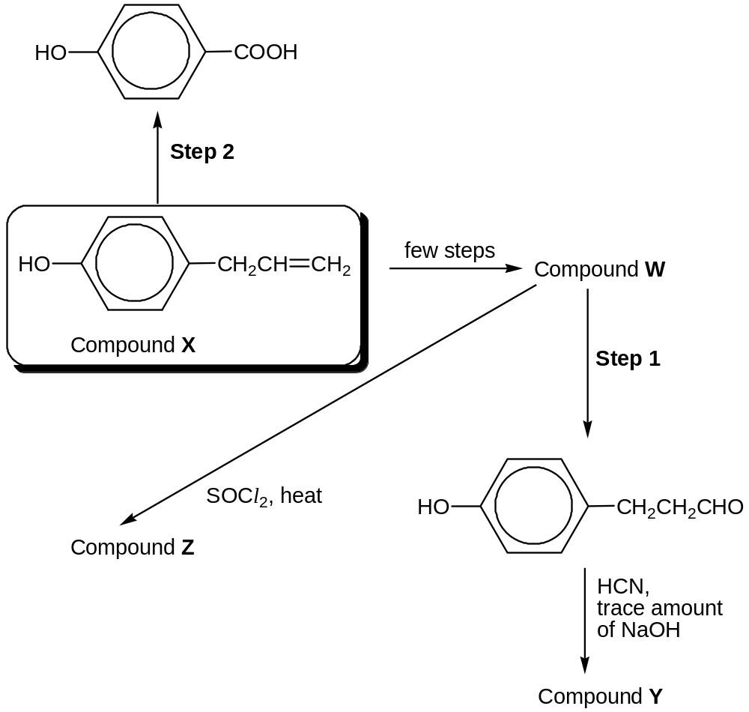

- Draw the structures of compounds W, Y and Z in the boxes below.

W | Y | Z

- Suggest the reagents and conditions necessary for the following steps.

Step 1:

Step 2:

[5]
[Total: 10]

Section B (40 marks)

Answer two questions from this section on separate answer paper.

6 (a) The bicarbonate buffering system is an important buffer system in the acid-base homeostasis of living things, including humans.

As a buffer, it tends to maintain a relatively constant blood plasma pH and counteract any force that would alter it. Thus blood pH is regulated to stay within the narrow range of 7.35 to 7.45, making it slightly alkaline. If the pH of the body gets too low (below 7.4), a condition known as acidosis results. This can be very serious, because many of the chemical reactions that occur in the body, especially those involving proteins, are pH-dependent.

In this buffering system, carbon dioxide combines with water to form carbonic acid (H₂CO₃), which in turn rapidly dissociates to form hydrogen and bicarbonate (HCO₃⁻) ions according to the reaction below:
H₂CO₃ HCO₃⁻ + H⁺ K_{a} = 7.95 x 10⁻⁷ mol dm⁻³

- Define pH.

- Identify the conjugate acid-base pair in the above buffering system.

- With the aid of an equation, explain how this buffering system helps to maintain relatively constant pH when H⁺ ions are added to the blood plasma.

- Calculate pH of a 0.10 mol dm⁻³ solution of carbonic acid.

- 25 cm³ of carbonic acid was reacted with 30 cm³ of 0.60 mol dm⁻³ of aqueous sodium hydroxide. Calculate the pH of the reaction mixture. (You may wish to consider carbonic acid as a monobasic acid.)

- Suggest a suitable indicator for the titration in (a) (v).

- Is carbonic acid a strong or weak acid? Explain your answer.
[10]

(b) The composition of the human body can be looked at from different points of view. By mass, oxygen, hydrogen and carbon are present in larger abundances. Other elements which are present include sodium, magnesium, phosphorus, sulfur and chlorine. Aluminium, which is another element found in Period 3, seems to serve no function in living cells. Rather, it is harmful in large amounts.

- When sodium chloride is added to water, the solution formed has a pH of 7. When aluminium chloride is added to water, the resulting solution has a pH of 3. Explain these observations, and why these two chlorides differ in their reaction with water.

(ii) Beryllium, which shares a diagonal relationship with aluminium, undergoes similar chemical reactions as aluminium. By means of balanced equations, indicate whether or not beryllium oxide reacts with:

I NaOH(aq)
II HCl(aq)

- Magnesium oxide is only slightly soluble in water but it dissolves in aqueous magnesium chloride. Explain this observation with the aid of balanced equations.
[8]

(c) The chloride of an element X in Period 3 is a liquid which has a boiling point of 58 ºC.

After dissolving 0.0100 mol of the chloride with water, the resulting solution required 100 cm³ of 0.400 mol dm⁻³ silver nitrate for complete precipitation of the chloride ion.

To which group of the Periodic Table does X belong?
[2]

[Total: 20]

7 (a) Compound P, C₅H₉ClO₂, which is sparingly soluble in water, is readily soluble in aqueous sodium hydroxide.

Heating compound P in aqueous sodium hydroxide and adding excess acid to the product give compound Q, C₅H₁₀O₃. Q reacts with warm alkaline aqueous iodine to give a yellow precipitate.

When compound Q is refluxed with concentrated sulfuric acid, it forms 3 isomers, R, S and T with a molecular formula of C₅H₈O₂. R is a sweet smelling liquid and S and T exist as a pair of geometric isomers. S also reacts with aqueous bromine to give a number of products, one of which is shown below:

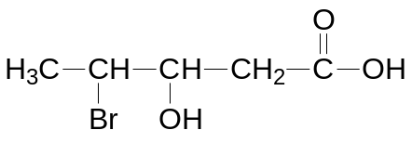

S undergoes reaction with acidified potassium manganate(VII) to give U, C₃H₄O₄, and ethanoic acid. 1 mole of U liberates 1 mole of CO₂ on reaction with excess sodium carbonate.

- Deduce the structures of compounds P, Q, R, S, T and U, explaining how you arrive at your answers.

- Write balanced equations for the reaction of:

I P with aqueous sodium hydroxide;
II Q with warm alkaline aqueous iodine.
[13]

(b) Iodination of propanone is done in aqueous acidic solution according to the equation:

CH₃COCH₃(aq) + I₂(aq) → CH₃COCH₂I(aq) + H⁺(aq) + I⁻(aq)

In investigations of this reaction, the following results were obtained.

Experiment No. | Initial concentrations of reactants/ mol dm⁻³ |  |  | Initial rate of reaction/  mol dm⁻³ min⁻¹
Experiment No. | [CH₃COCH₃] | [H⁺] | [I₂]
1 | 0.4 | 0.4 | 0.002 | 1.01 x 10⁻⁴
2 | 0.4 | 0.8 | 0.002 | 2.02 x 10⁻⁴
3 | 1.2 | 0.4 | 0.002 | 3.03 x 10⁻⁴
4 | 1.2 | 0.8 | 0.004 | 6.06 x 10⁻⁴

(i) Using the data above, deduce the orders of reaction with respect to propanone, iodine and acid.

(ii) Construct a rate equation for the reaction and use it to calculate a value for the rate constant.

- With the aid of an appropriate diagram, explain how the rate of reaction will be affected by a decrease in temperature.
[7]

[Total: 20]

8 (a) A compound W, C₆H₈O, when reacted with excess hydrogen in the presence of nickel catalyst gives compound X, C₆H₁₂O. X reacts with sodium metal to give hydrogen gas.

W gives an orange precipitate with 2,4 dinitrophenylhydrazine but there is no reaction with Tollens’ reagent .

When compound W reacts with bromine, the reddish-brown bromine decolourised and forms compound Y, C₆H₈Br₂O. With HCN, W forms compound Z, C₇H₉NO.

Deduce the structures of compounds W, X, Y, and Z. Write balanced equations for the reactions involved where appropriate.
[10]

(b) Chlorofluorocarbons, CFCs, are widely used as refrigerants, propellants (in aerosol applications), and solvents. The manufacture of such compounds is being phased out by the Montreal Protocol because of their contribution to ozone depletion.

A typical chlorofluorocarbon is 2-chloro-1,1,1,2-tetrafluoroethane (CHFClCF₃).

(i) Which covalent bond in the above CFC is the weakest? Give a reason for your answer.

(ii) How will the boiling point of the above CFC differ from that of CClF₂CF₂CHClF?
[4]

(c) Chlorine dioxide, ClO₂, is now commonly used in water treatment due to its greater solubility in water compared to chlorine.

- Draw the dot−and−cross diagram for chlorine dioxide and suggest the shape and the size of its bond angle.
- Suggest a reason why chlorine dioxide is a good oxidizing agent.
- Explain why chlorine dioxide is relatively more soluble in water compared to chlorine. Draw a diagram to illustrate your answer.
[6]

[Total: 20]

END OF PAPER

